Date:27th-July-2021  
**Reference Dashboard Design**

**Below are couple of reference screenshots of a dashboard with differet slicers applied.   
  
2021 Year selected in Year slicer:  
  
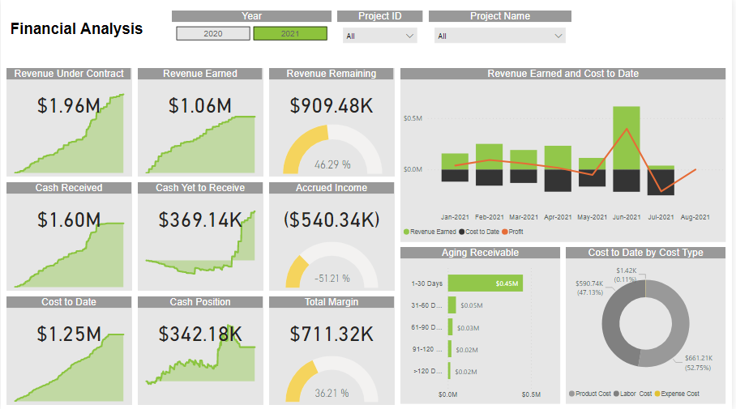  
  
2. 2020 Year selected in Year slicer.**

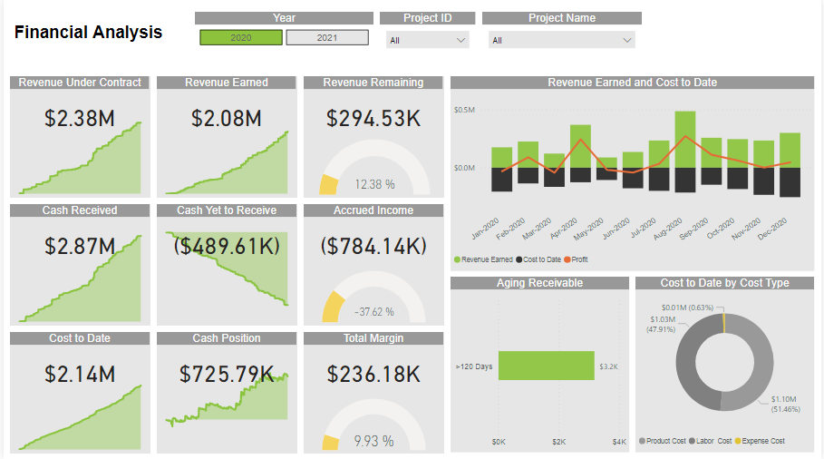

**Both 2021 and 2020 are selected in Year slicer:**

**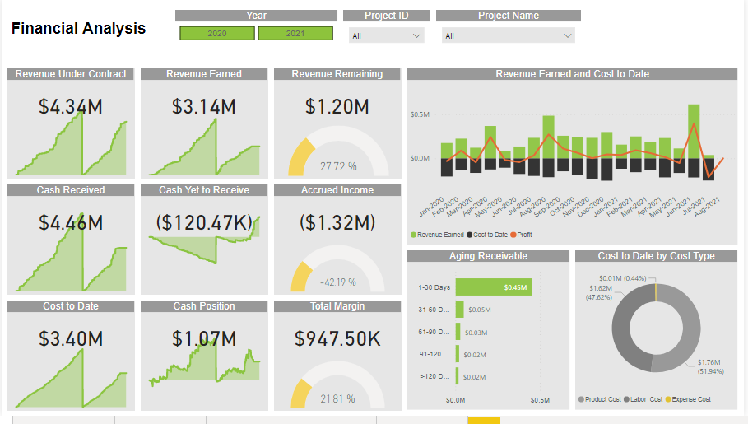  
  
Project ID 568 data for 2021  
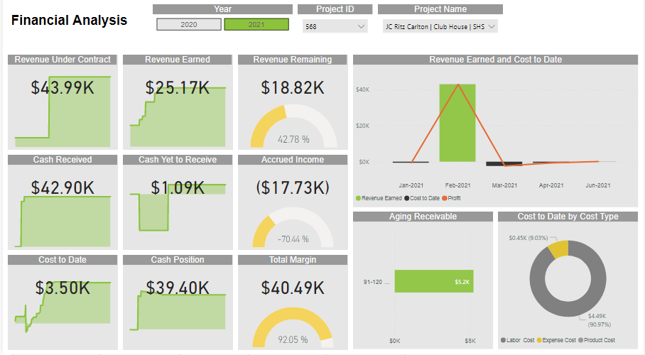  
Project ID 568 data for both 2021 and 2020  
